# PDIoT Data Collection Protocol

Welcome to PDIoT 2020! This year your task will be to develop a Human Activity Recognition for classifying the following activities:

* Sitting/Standing
* Lying down
* Walking
* Running/Jogging
* Ascending and descending stairs
* Desk work (working at a computer, writing, etc.)

Note that you are free to add other activities to this list.

In the first week of the course, you will collect data using the Respeck and the PDIoT App, then add the data to a shared repository. You will be asked to collect data for the activities above wearing the sensor in 6 different positions and perform each activity for at least 30 seconds. This way, everyone will have access to the same amount of data, regardless of which position of the sensor they choose to develop their HAR model for.

The positions of the sensor can be:

* Chest
* Front pocket of the trouser
* Wrist

Each of these positions can be on the left and right side. Hence the 6 total positions.

## Downloading the PDIoT App

You will need an Android phone running Android 6.0 or above to successfully install the app. Please let us know if you do not have access to an Android phone. The application code can be found here:

<https://github.com/specknet/pdiotapp>

Download the repository on your local machine and open the project using Android Studio. Once the code loads, go to Build > Build Bundle(s) / APK(s) > Build APK. This will build a .apk file and save it in the project folder > app > build > outputs > apk > debug > app-debug.apk. You can then transfer this apk file to your phone and start the application.

Alternatively, if you have developer options enabled on your Android phone, you can build the app directly from Android Studio by selecting Run > Run app.

## Connecting to the Respeck

When you first install the application, you will need to connect it to the Respeck. Do so by navigating to the *Connect Respeck*activity. Here you will see a status bar for the Respeck connection on the top right, a button to scan the Respeck and an input field where you can manually input the Resepck code or MAC address.

Every Respeck has a QR code printed on its back. By pressing the *Scan Respeck* button, a camera view will pop up and you will be able to scan the Respeck QR code to pair it to your app. Only one Respeck can be paired with an app at one time.

The Respeck ID will automatically appear in its place. You can then press the *Connect* button to pair the app with the Respeck. You can press the *Disconnect* button to disconnect from the sensor, but note that this doesn’t unpair the Respeck. If you want to unpair the respeck you need to scan a new one.

You can view the live signals coming from the sensor in the *Watch Live Processing* activity. If you do not see any signals, it means that the Respeck is not properly connected.

Finally, you can record data in the *Record Data* activity. Choose the appropriate Sensor position, side, activity and please use the university student number as the subject ID. Hit *Start Recording* when you are all set up.

## Recording data

As mentioned before, you will be collecting data from 6 different positions of the sensor:

* Chest (left and right)
* Front trouser pocket (left and right)
* Wrist (left and right)

To ensure that everyone has access to good data, please follow these instructions when wearing the sensors.

Before working with the sensor place it in one of the small plastic bags that have been provided to you. This will help keep it clean and non-sticky.

### Chest

When wearing the sensor on the chest, place it under the lower side ribcage (just where your last ribs end). Make sure that the Respeck label is facing you and that it is facing the right way up, regardless of whether you place it on your left or right side. You can secure it to the chest using the MeFix tape you were given in the lab. Here is an illustration.

### Front trouser pocket

The Respeck placement in the pocket should be similar to the chest – label facing toward you such that you can read it. Here is an illustration.

### Wrist

The Respeck should be still worn with the label to your skin, however, for better securement of the sensor, please place it with the QR code aimed towards your elbow. The illustration below shows this on the left hand. Please keep the same orientation of the Respeck on your right hand.

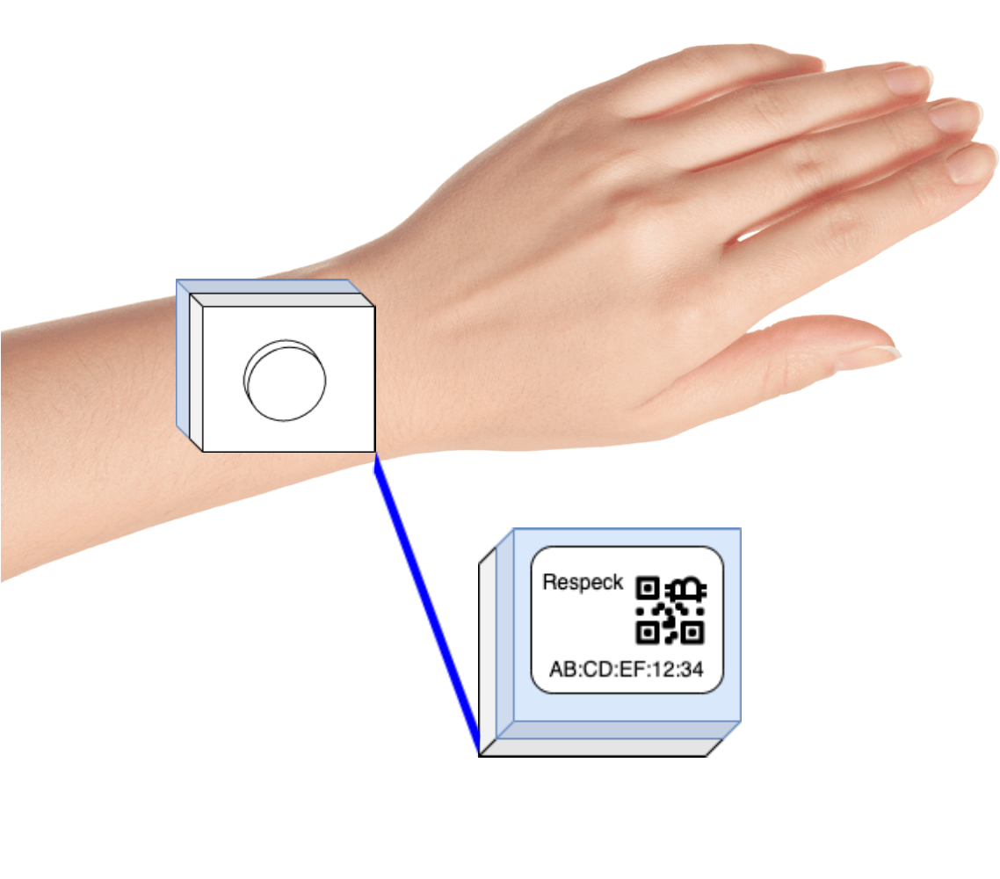

### Activities

Please perform each activity for at least 30 seconds. The app contains more granular labels for activities such as Sitting down and Lying down (front, back etc). You should have *84 recordings* in total (14 * 3 * 2), which amounts to *42 minutes* of data for each person in the class. If you need more data for your models, you can recruit your own volunteers from your friend group to help with the data collection. Remember – the more data, the better the models will learn.

### Uploading the data

The data will be available in the phone internal memory, typically in a folder called *com.specknet.pdiotapp/files/recording.csv*. Please keep the original names and upload the files to the PDIoT shared data repository: <https://github.com/specknet/pdiot-data>.